Contents

Introduction 2

OEM License Information 2

Object CRUD Access Comparison 2

MCA App Feature wise comparison 3

Development Effort Estimates 5

# Introduction

This document enlists the considerations and aspects to be made for creating applications leveraging the OEM Model for Salesforce AppExchange Market place.

# OEM License Information

Referred to as the OEM Embedded license is nothing but a full Force.com license with contractual restrictions. This license restricts the Create, Read, Update and Delete functionality on the following standard Salesforce objects as they are unavailable to users using this license.

* Leads
* Opportunities
* Products
* Cases
* Solutions
* Campaigns

# Object CRUD Access Comparison

The below snapshot provides details of the CRUD capabilities available for the standard Salesforce objects for users having OEM Embedded licenses.

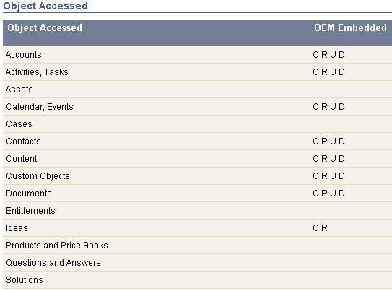

# MCA App Feature wise comparison

The below section outlines the details of all the objects leveraged in the MCA App and the functionalities using them.

|  |  |  |  |
| --- | --- | --- | --- |
| **Sr. No.** | **Object** | **Object Type** | **Functionality** |
| 1 | Account | Standard | Funding Application, Bank Tab, ISO Tab, Banking CC Functionality |
| 2 | Contact | Standard | Funding Application |
| 3 | Opportunity | Standard | Funding Application, Submission Wizard, Activity Count , Create Contract, MCA Home Page, Manage Renewals, Offer Wizard |
| 4 | Lead | Standard | Activity Count |
| 5 | Contract | Standard | Manage Renewals, Track Stage changes |
| 6 | Campaign | Standard | Report, Dashboard, MCA Home Page |
| 7 | Program | Custom | Submission Wizard, MCA Home Page |
| 8 | Submission | Custom | Submission Wizard |
| 9 | STIPS | Custom | Roll Up on Opportunity |
| 10 | Syndication | Custom | Report, Dashboard, MCA Home Page |
| 11 | Transaction | Custom | Transaction Functionality |
| 12 | Line Item | Custom |  |
| 13 | Payable | Custom | Transaction Functionality |
| 14 | Payable Line Item | Custom |  |
| 15 | Receivable | Custom | Transaction Functionality |
| 16 | Receivable Line Item Summary | Custom |  |
| 17 | Transaction | Custom | Transaction Functionality |
| 18 | Transaction Line Credit | Custom | Transaction Functionality |
| 19 | Transaction Line Debit | Custom | Transaction Functionality |
| 20 | Offer | Custom | Offer Wizard |
| 21 | Bank Statements | Custom | Banking CC Functionality |
| 22 | Credit Card Sales | Custom | Banking CC Functionality |
| 23 | Required Document | Custom | Submission Wizard |
| 24 | Loan Balance | Custom | Roll Up on Opportunity |
| 25 | Assignment Group | Custom |  |
| 26 | Group Member | Standard |  |

The below table enlists the standard objects that are not available in the OEM model and the MCA functionalities dependent on them that would require custom development.

|  |  |  |
| --- | --- | --- |
| **Sr. No.** | **Object** | **Dependent MCA Functionality** |
| 1 | Opportunity | 1. Funding Application 2. Submission Wizard 3. Activity Count 4. Create Contract 5. MCA Home Page 6. Manage Renewals 7. Offer Wizard |
| 2 | Lead | 1. Activity Count |
| 3 | Contract | 1. Manage Renewals 2. Track Stage changes |
| 4 | Campaign | 1. Report 2. Dashboard 3. MCA Home Page |

# Development Effort Estimates

The below table outlines only the ballpark development effort that would be required to transform the MCA App to an OEM compliant app. The effort in the below table does not account for – Test Code development Deployment / QA / Bug Fixes and Packaging.

|  |  |  |  |
| --- | --- | --- | --- |
| **Sr. No.** | **Object Name / Functionality** | **Solution** | **Effort (Hrs.)** |
| 1 | Lead / Opportunity / Campaign / Contract | Creating a custom Object with the necessary custom fields for Lead / Campaign / Contract. | 9 |
| 2 | MCA Custom Objects | Data Model Changes to the existing custom objects | 8 |
| 3 | Lead | Replicating the out of box functionality for Lead Conversion to Opportunity using custom code and page | 32 |
| 4 | Opportunity | Replicating the standard out of box functionalities for Opportunities using custom development like OpportunityContactRoles etc. | 24 |
| 5 | Campaign | Replicating the standard out of box functionalities for Campaign using custom development | 24 |
| 6 | Funding Application | Replicating Funding Application functionality on Custom Opportunity | 12 |
| 7 | Submission Wizard | Replicating Submission Wizard functionality on Custom Opportunity | 9 |
| 8 | Activity Count | Replicating Opportunity and Lead Count feature on Tasks / Events | 9 |
| 9 | Create Contract | Replicating Create Contract functionality for Custom Opportunity | 10 |
| 10 | Manage Renewals | Replicating Manage Renewals functionality for Custom Opportunity and Contract | 24 |
| 11 | Offer Wizard | Conga Queries, Template Creation | 6 |
| 12 | MCA Home | Visualforce code changes for the MCA Home Page to calculate the metrics from the custom Lead and Opportunity object | 5 |
| 13 | Opportunity Trigger | Code modifications to reflect the Stage changes on Opportunity on Contract | 10 |
| 14 | Workflows | Deployment/ Replicate the ones on Opportunity and Lead and Contract | 8 |
| 15 | Reports | Around 20 Custom Reports on Lead / Opportunity would need to be redeveloped | 12 |
| 16 | Dashboards | Around 4 Dashboards each having atleast 6 - 10 components need to be redeveloped | 12 |
| **Total Development Effort (Hrs.)** | | | **214** |